**IT SUPPORT TICKET MANAGEMENT SYSTEM ANALYSIS**

**Objective Questions:**

**Q1. What is the total no. of attributes present in the data?**

**Answer:**

**Formula:** = COUNTA(A1:J1)+COUNTA(Sheet2!A1:F1)

There are 16 attributes present in the data stored within two sheets, “Tickets” and “IT Agents.” These are:

**Tickets Sheet:**

* **ID Ticket:** Identifier of the ticket.
* **Fecha:** Ticket date.
* **Employee ID:** ID of the employee who issued the ticket.
* **Agent ID:** ID of the agent assigned to the ticket.
* **Request Category:** (Login Access, System, Software).
* **Issue Type:** (IT Error, IT Request).
* **Severity**: Issue severity.
* **Priority**: Priority level of the issue.
* **Resolution Time (Days):** Days taken for ticket resolution.
* **Satisfaction Rate:** Satisfaction level provided by the employee

**IT Agents Sheet:**

* **Agent ID:** Agent identifier.
* **Full Name:** Full name of the agent.
* **Email:** Email address of the agent.
* **Year of Birth:** Year the agent was born.
* **Month of Birth:** Month the agent was born.
* **Day of Birth:** Day the agent was born.

**Q2. Which columns have inconsistent or missing values, and what is the count of such values?**

**Answer:**

**Formula to count missing values:** =COUNTBLANK(A1:J97499)+COUNTBLANK(Sheet2!A1:F51)

There are 0 missing values in the dataset.

**Procedure to find inconsistent values:** Filter from “Sort and Filter” to reveal all the values from each column. Manual checking of the values from each column for inconsistencies.

There are no inconsistencies in the data set.

**Q3. What is the average daily ticket volume over time?**

**Answer:** 53.36508

**Formula:** =AVERAGE(B4:B1830)

**Visualization:**

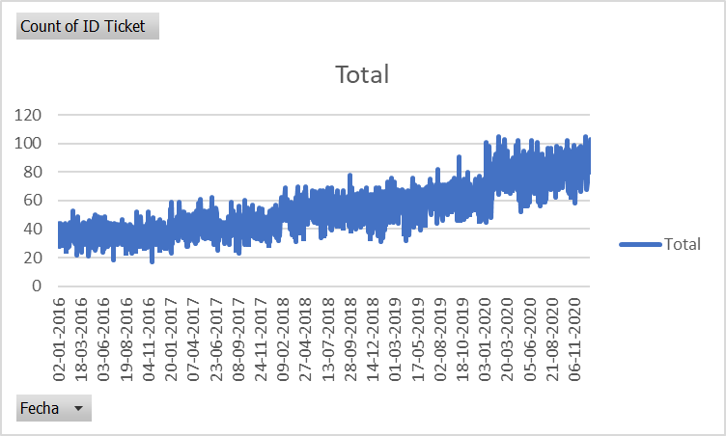

**Observation:** The daily volume of tickets has increased over time and reached from 20-40 to 90-110 from 2016 to 2020.

**Q4. What is the distribution of ticket categories (e.g., Login Access, System, Software)?**

**Answer:** The distribution of tickets categories is 9733, 29193, 19570, 39002 as Hardware, Login Access, Software and System respectively. This makes around 10%, 30%, 20% and 40% respectively.

**Visualisation:**

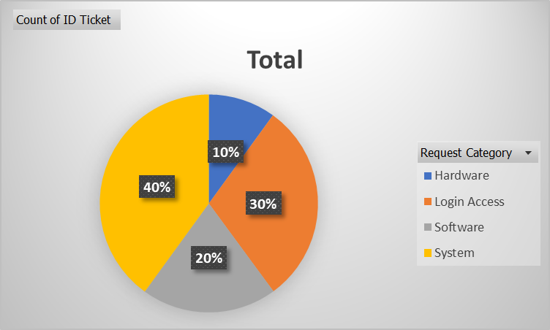

**Q5. How many tickets has each agent handled?**

**Answer:**

**Visualization:**

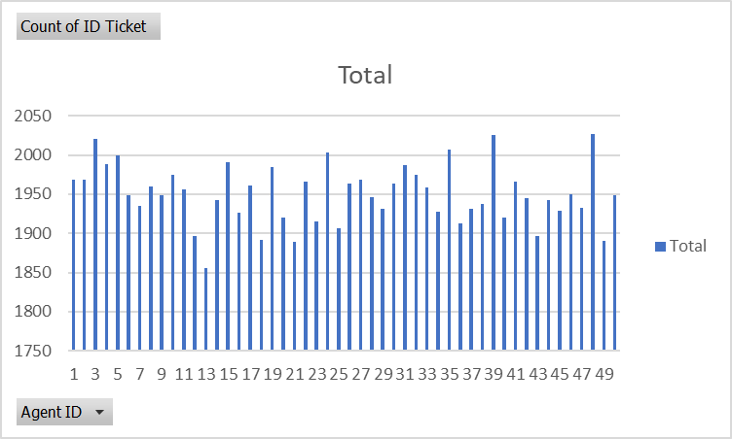

**Observation:**

* Each agent has handled around 2 percent of the total tickets.
* Minimum number of tickets an agent handled: 1856
* Maximum number of tickets an agent handled: 2027

**Q6. How can you extract the domain from the email addresses in the IT Agents sheet?**

**Answer:**

**Formula:** =LEFT(RIGHT(C2, LEN(C2) - FIND("@", C2)), FIND(".", RIGHT(C2, LEN(C2) - FIND("@", C2))) - 1)

**Observation:** All the agents have the same domain in their emails, fp20analytics

**Q7. How can you find the full name of an agent given their Agent ID?**

**Answer:** The full name of the agent can be found using the VLOOKUP Function.

**Formula:** =VLOOKUP(D2,Sheet2!$A$1:$G$51,2,0)

**Q8. What is the count of each issue type (e.g., IT Error, IT Request)?**

**Answer:** The count is 24278 and 73220 for IT Error and IT Request respectively.

**Visualization:**

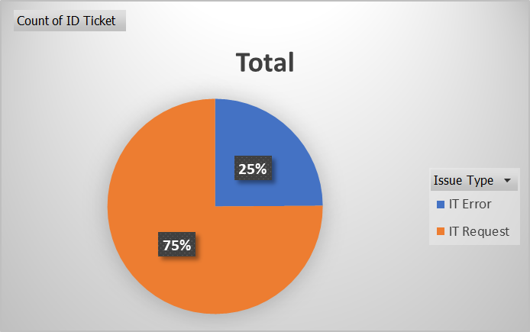

**Observation****:** IT Error consists around 25% of the tickets and IT Requests consists around 75%.

**Q9. What is the daily average resolution time for tickets?**

**Answer:** 4.553149808

**Formula:** =AVERAGE(I2:I97499)

**Q10. How has the volume of tickets changed over time?**

**Answer:**

**Visualization:**



**Observation:** The daily volume of tickets has increased over time and reached from 20-40 to 90-110 from 2016 to 2020.

**Q11. What is the average age of the IT agents?**

**Answer:** 39.38

**Approach:** Create a column to get the date of birth from year of birth, month of birth and day of birth. Then use the DATEDIF function to find the difference between the date of birth and TODAY(), giving years as the unit. Then find average using the average function.

**FORMULAE:** =DATE(D2,E2,F2) =DATEDIF(H2, TODAY(),"Y") =AVERAGE(I2:I51)

**Q12. Is there a correlation between the severity of issues and the resolution time?**

**Answer:** -0.040536349

**Formula:** =CORREL(L2:L97499,I2:I97499)

**Q13. How many categorical columns are there in the data? [Search about categorical and continuous data, and try to answer this question]**

**Answer:** There are 4 categorical columns in the data, namely request category, issue type, severity and priority. And there are 2 continuous columns in the data, namely satisfaction rate and resolution time.

**Subjective Questions:**

**Q1. If there is an investment, should it be used to hire more IT agents, improve training programs, or upgrade ticket management software?**

**Analysis: Perform a cost-benefit analysis using ticket resolution and satisfaction metrics.**

**Answer:**

**Visualization:**

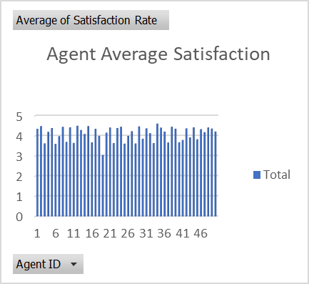

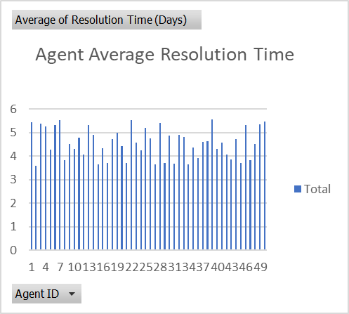

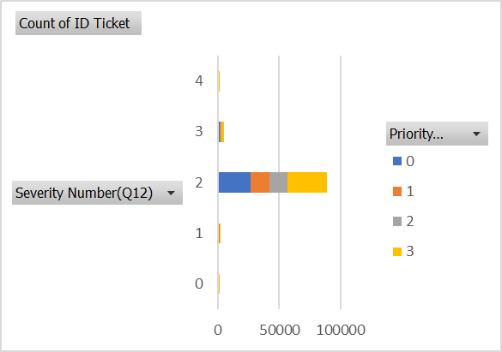

**Pivot Tables:**



**Ratio of these averages:**



**Grand Total: 0.9006179**



**Insights:**

* Agent performance: These charts and tables help us understand agent performance based on satisfaction ratings and resolution time.
* For severity level 0, most tickets are assigned to priority levels 0 and 1, which seems appropriate. However, second highest priority level for 0 severity is 3, which makes no sense.
* For medium level severity (1,2), the tickets should be more highly concentrated in priority levels 1 and 2. However, they are more highly concentrated in levels 0 and 3.
* For high severity levels (3,4), most tickets are in priority level 3 which is appropriate, but after that the second highest number is in priority level 0 which is problematic.

**Recommendations:**

* Invest in training: The grand total of ratio of average satisfaction rating and average resolution time is 0.9. Agents with the ratio less than 0.9 should be given training.
* The current software tools are not as effective in managing tickets as desired. Investments should be made in improving them or new tools should be implemented.

**Q2. Which agents need additional training based on their performance metrics?**

**Analysis: Identify agents with the lowest satisfaction ratings and longest resolution times.**

**Answer:**

**Visualisation:**





**Pivot Tables:**





**Insights:**

* Average satisfaction rating: The charts and tables show us the average satisfaction rating for each agent.
* Average time of resolution: The charts and tables show us the average time of resolution taken by each agent.
* Ratio of average satisfaction rating and average time of resolution: The pivot table shows us the ratio of average satisfaction rating and average time of resolution for each agent.

**Recommendations:**

* Invest in training: Invest in training of agents with average satisfaction rates less than 4. Also invest in training of agents with average time of resolution more than 4. Also, the grand total of ratio of average satisfaction rating and average resolution time is 0.9. Agents with the ratio less than 0.9 should be given training.

**Q3. Do certain categories of requests have longer resolution times?**

**Analysis: Analyse the resolution times by request category.**

**Answer:**

**Visualisation:**

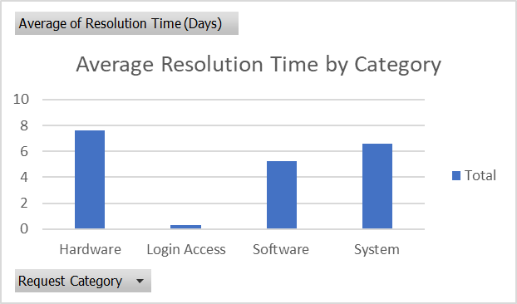

**Pivot Table:**

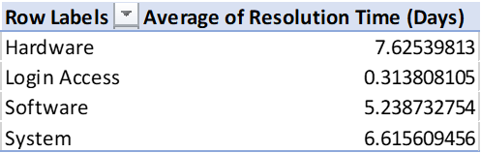

**Insights:**

* This chart and table show us the average of resolution time in days for each request category.

**Recommendations:**

* Investments should be made in certain categories like Hardware, Software and System.

**Q4. How effective are the current software tools in managing IT tickets?**

**Analysis: Evaluate performance metrics before and after the implementation of new tools.**

**Answer:**

**Pivot Table:**



**Visualization:**



**Insights:**

* For severity level 0, most tickets are assigned to priority levels 0 and 1, which seems appropriate. However, second highest priority level for 0 severity is 3, which makes no sense.
* For medium level severity (1,2), the tickets should be more highly concentrated in priority levels 1 and 2. However, they are more highly concentrated in levels 0 and 3.
* For high severity levels (3,4), most tickets are in priority level 3 which is appropriate, but after that the second highest number is in priority level 0 which is problematic.

**Recommendations:**

* The current software tools are not as effective in managing tickets as desired. Investments should be made in improving them or new tools should be implemented.

**Q5. How has the performance of the IT support team changed over time (e.g., monthly or quarterly)?**

**Analysis: Trend analysis using time series charts.**

**Answer:**

**Visualisation:**

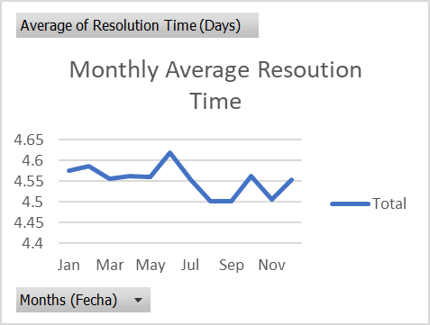

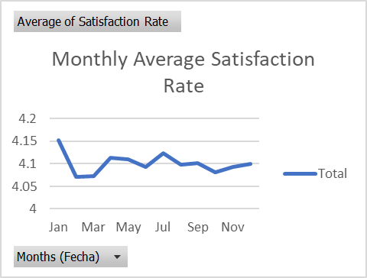

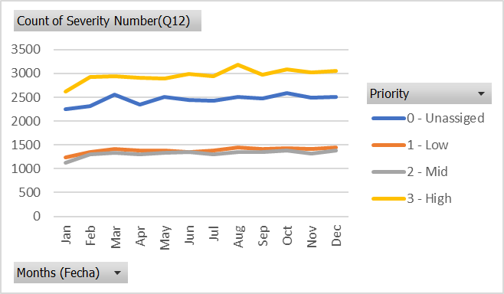

**(Made this chart using count of severity because average of severity gave divided by zero error)**

**Pivot Tables:**





**(Error being showed in the pivot table where monthly comparison of priority and severity was attempted)**

**Insights:**

* The charts and tables help us understand the monthly average time of ticket resolution.
* The charts and tables help us understand the monthly average satisfaction rate of employees
* **The monthly comparison of priority and severity remained unchecked due to the error (divided by zero)**

**Observation:**

* The average monthly resolution time of tickets largely remained constant. There were minor drops in July-September and November, and a minor peak during May-July.
* The average monthly satisfaction rate of employees largely remained constant. There was a minor drop before March and a minor peak in January.
* **The monthly comparison of priority and severity remained unchecked due to the error (divided by zero)**

**Q6. If we invest more on tech (Hardware, software, etc), do you think it will improve the ticket resolution times and employee satisfaction?**

**Analysis: Use historical data to project potential improvements.**

**Answer:**

**Visualization:**

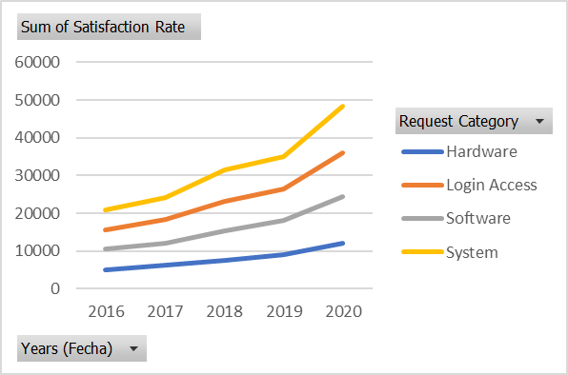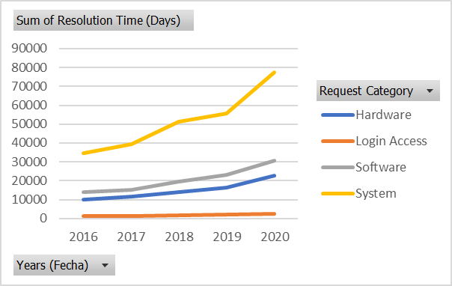

**Pivot Tables:**









**Insights:**

* The pivot tables and charts help us see the trends in average satisfaction rates and resolution time over the years.
* The pivot tables and charts help us see the trends in sum of satisfaction rates and resolution time (in days) over the years.

**Observations:**

* Over the years, while the average of satisfaction rates and resolution time has largely remained the same, the sum of satisfaction rates and resolution time has increased, which means more tickets have been resolved. So, investing in technology like hardware, software has not necessarily improved ticket resolution times and satisfaction rates, but has helped in resolving more tickets.

**Recommendations:**

* Invest in technology to further increase the number of resolved tickets per year.

**Q7. What are the key performance metrics for IT agents, and how can they be improved, do we need to fire any agents?**

**Analysis: Define and analyse metrics such as average handling time, satisfaction scores, and number of tickets resolved.**

**Answer:**

**Visualisation:**

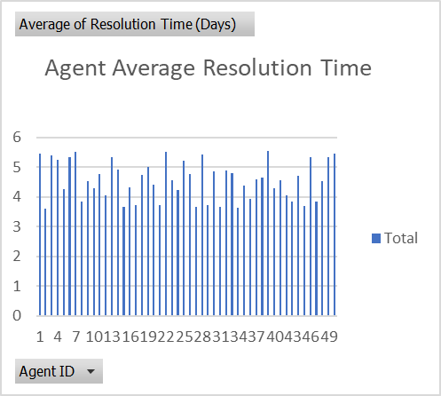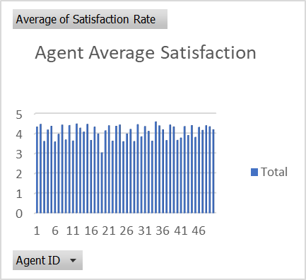

**Pivot Tables:**





**The key performance metrics for IT agents are average resolution time, average satisfaction ratings and count of tickets.**

**Insights:**

* Average Satisfaction Ratings: The tables and charts show us the average satisfaction ratings provided by each agent
* Average Resolution Time: The tables and charts show us the average resolution time taken by each agent
* Count of tickets: The tables and charts show us the count of tickets handled by each agent.

**Recommendations:**

* For these metrics to be improved, training can be given to the agents. For example, agents with average satisfaction rating less than 4, agents with average resolution time more than 4 days, and agents who have handled less than 1900 tickets should be given training. Also, there are agents with the ratio of average satisfaction rating and average time of resolution less than 0.9, they should be given training.
* We don’t need to fire any agents because there are no drastic differences in performances. The ones who slightly lag behind can be provided with some training to improve their metrics.

**Q8.** **How do employee demographics (e.g., department, seniority) impact satisfaction and ticket outcomes?**

**Analysis: Segment analysis using filters and pivot tables.**

**Answer:**

**Visualisation:**

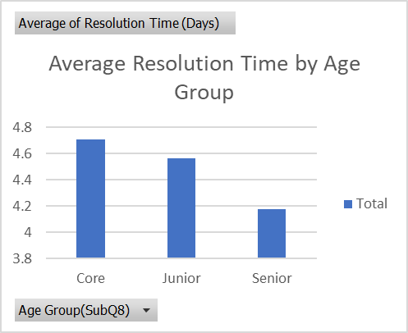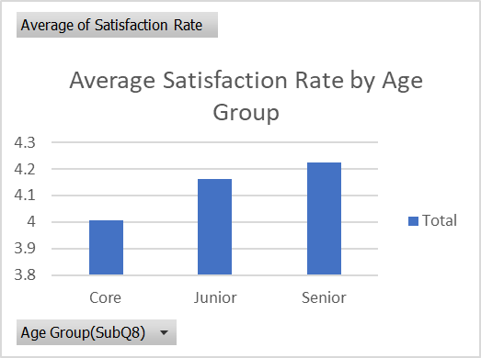

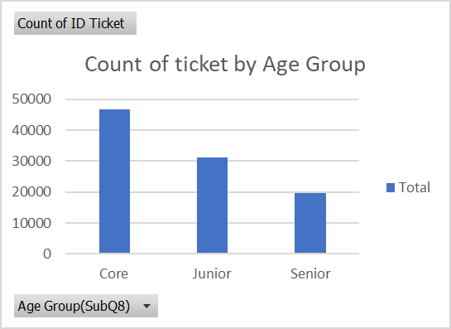

**Pivot Tables:**







**Insights:**

* The core agents have performed worse than the junior agents in some metrics (average resolution time and satisfaction ratings). However, the difference is not that significant.
* There is noticeable difference between core agents and senior agents when it comes to average resolution time.
* Senior agents have better performances when it comes to average resolution time and average satisfaction rating but have not solved as many tickets as junior and core agents; there is a huge difference, which is problematic.

**Recommendations:**

* Investing in training programs of core agents so that they can manage time better and reduce the average resolution time
* Though senior agents have outperformed core and junior agents in other metrics, their count of ticket is considerably low. It would be smart to fire them, and train core agents and junior agents to perform better (especially average resolution time).

**Q9. Identify the trends for IT support operations based on ticket volumes and satisfaction, and mention the peak and stable times?**

**Analysis: Use pivot tables and charts to identify peak and off-peak hours.**

**Answer:**

**Visualisation:**

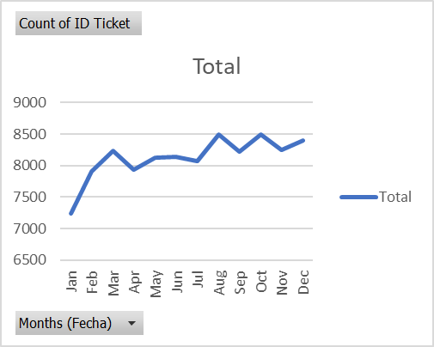

**\* Unable to paste the other chart, monthly average satisfaction (which was largely constant) \***

**Pivot Tables:**



**Observations:**

* The count of ticket increases from January to March, with a stable period from April to July, peaking in August and October.
* The average of satisfaction rate remains largely constant.

**Q10. What metrics should be included in the final dashboard to provide a comprehensive view of call center performance and guide investment decisions?**

**Answer:** These metrics should be included in the final dashboard:

* Count of ticket IDs by time.
* Count of tickets by request category.
* Satisfaction rate by time.
* Average resolution time by request category (quarter-wise).
* Age group by satisfaction rate.
* Ticket count by severity rate.
* Distribution of tickets based on satisfaction scores.
* Distribution of tickets based on resolution times